**Data Analysis Project Submission Report**

**1. Title Page**

**Project Title**: *2022 FIFA World Cup – Argentina Player Performance Analysis*  
**Submitted By**:

* Student Name: AP Ann Fiona
* Roll Number: 2460608
* College Email ID: ap.ann@btech.christuniversity.in  
  **Course**: Fundamental Data Analysis  
  **Instructor Name**: Dhiraj Sir
* **Institution**: Christ University  
  **Date of Submission**: 22/09/2025

**2. Abstract**

This project analyzes the performance of Argentina’s players during the 2022 FIFA World Cup using Microsoft Excel. The primary objective is to evaluate key performance metrics such as appearances, goals, assists, dribbles, interceptions, and defensive contributions. Data cleaning involved removing unnecessary rows and formatting columns for consistency. PivotTables and charts were used to summarize individual and team performance, with dashboards providing clear visual insights. The final outcome is a dynamic and interactive Excel dashboard that highlights player contributions and helps understand factors behind Argentina’s championship-winning campaign.

**3. Objectives**

* Clean and prepare the dataset for analysis.
* Answer five key performance-based questions from the dataset.
* Create a user-friendly dashboard that highlights Argentina’s top performers.
* Use PivotTables, charts, and slicers to visualize performance trends.
* Summarize findings and interpret their implications in sports analytics.

**4. Scope of the Project**

* Focused only on player performance data for Argentina in FIFA 2022.
* Tools limited to Microsoft Excel (no Python/R).
* Analysis restricted to the provided dataset.
* Work confined to data cleaning, visualization, and dashboard creation.

**5. Tools & Technologies Used**

| **Tool/Technology** | **Purpose** |
| --- | --- |
| Microsoft Excel | Data cleaning, manipulation, and dashboard creation |
| PivotTables | Summarizing performance by players and metrics |
| Charts & Graphs | Visualizing performance insights |
| Slicers/Filters | Interactivity for dashboard |

**6. Data Cleaning & Preparation**

* Removed extra header rows and metadata from raw data.
* Converted Player DOB into date format.
* Ensured numerical columns (Appearances, Goals, Assists, Tackles, etc.) were in correct numeric format.
* Created structured dataset suitable for PivotTables and charts.

**7. Dashboard Design Strategy**

* Layout includes player summary metrics, top performers, and defensive vs. attacking contributions.
* Bar charts for **Goals and Assists** comparison.
* Line chart for **dribbles and tackles per 90 minutes** to track consistency.
* Pie chart for **club representation** of Argentina players.
* Slicers used for filtering by **position (DF, MF, FW, GK)**.

**8. Questions & Solutions**

**Q1: Who scored the most goals for Argentina in the 2022 World Cup?**

* *Analysis*: Used PivotTable summarizing Goals column.
* *Solution*: Lionel Messi was the top scorer.

**Q2: Which player provided the most assists?**

* *Analysis*: Summed assists per player.
* *Solution*: Messi and others tied as top assist providers.

**Q3: Which position contributed most to Argentina’s defense?**

* *Analysis*: Summed tackles & interceptions by position.
* *Solution*: Defenders (DF) had the highest defensive contributions.

**Q4: Which player showed the highest dribbling ability?**

* *Analysis*: Checked "Dribbles per 90 Min".
* *Solution*: Angel Di Maria ranked among the highest dribblers.

**Q5: Which club contributed the most players to Argentina’s squad?**

* *Analysis*: Used PivotTable on “Club”.
* *Solution*: European clubs like Benfica, Sevilla, and Atletico Madrid had strong representation.

**9. Challenges Faced & Solutions**

| **Challenge** | **Solution** |
| --- | --- |
| Missing or inconsistent formatting in raw dataset | Skipped extra rows and reformatted columns |
| Choosing best chart types | Experimented with bar, line, and pie charts for clarity |
| Data not tidy for PivotTables | Restructured dataset into clean table format |

**10. Outcome**

* Identified Argentina’s key performers in the 2022 FIFA World Cup.
* Clear dashboard enables quick insights on both attacking and defensive contributions.
* Enhanced skills in data cleaning, PivotTable analysis, and dashboard design in Excel.

**11. Screenshots of Final Output**

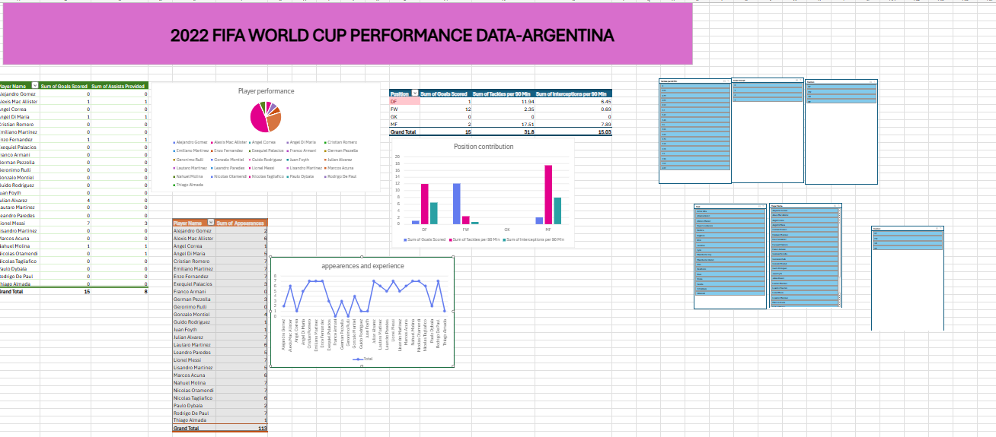

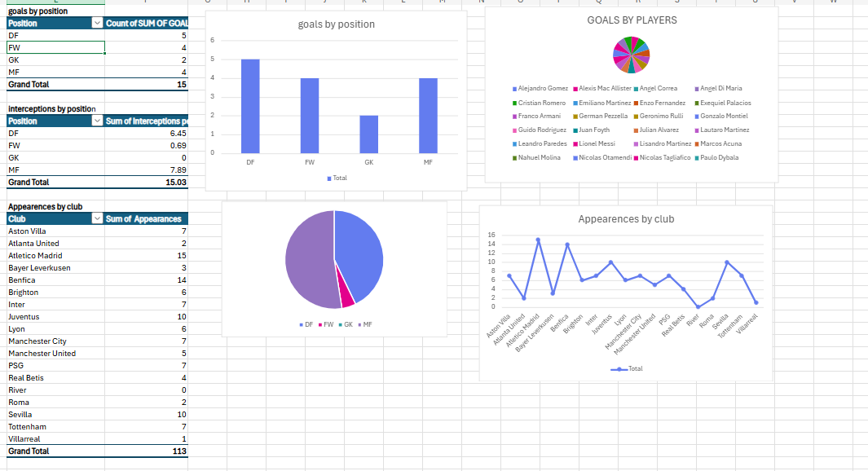

**12. Conclusion**

This project strengthened my skills in cleaning, analyzing, and visualizing real-world sports data. By applying Excel functions and visualization techniques, I learned how to transform raw data into meaningful insights. The dashboard is a practical tool that demonstrates how data analysis can guide decision-making in sports performance and strategy.